**Level 1: PC Tower Case**

**Outline**

Learn about the internals of a standard PC case by examining physical samples and selecting and labeling images found on-line. Gain deeper knowledge by researching and reporting on specific components.

**Questions**

1. Find one (or more) images that clearly show the internals of a PC Tower Case.   
   (i.e. Google images using keywords “PC Case Internals”)  
   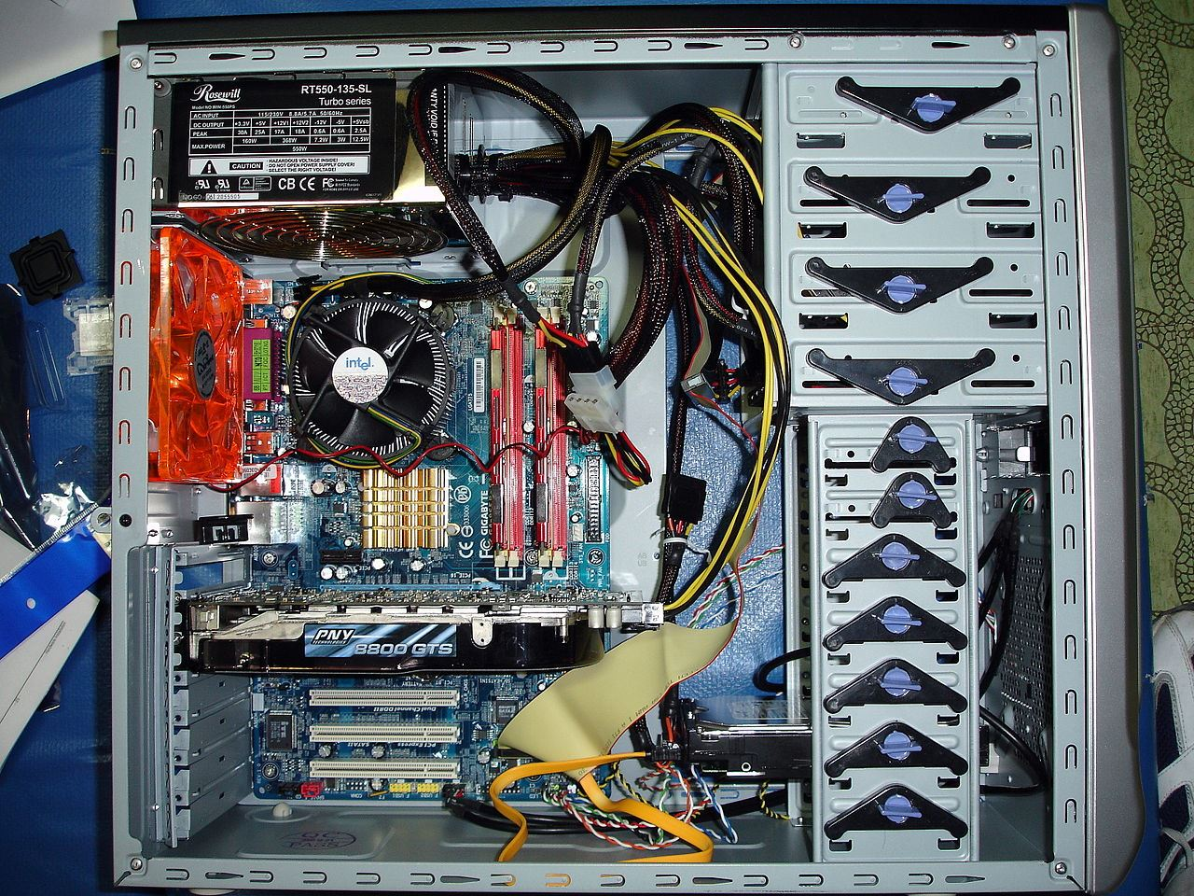

Fan

Motherboard Hard Disk Drive

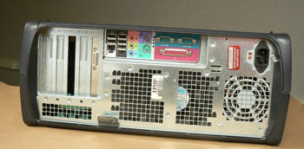

Ethernet Port USB Ports

Monitor Ports Power Supply

Audio Ports

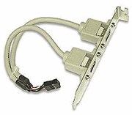

USB Expansion Port

Optical Disk Drive

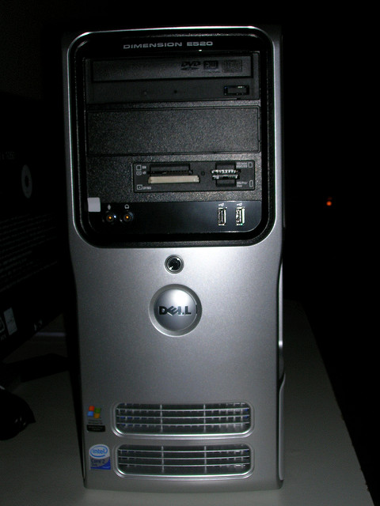

Clearly label the following components (using arrows) on your image of the PC case internals:

* 1. Motherboard
  2. Power Supply
  3. Hard Disk Drive
  4. Optical Disk Drive (e.g.DVD)
  5. USB Expansion Ports
  6. Monitor Port
  7. Audio Ports
  8. Ethernet Port
  9. Cooling Fan

1. Research more in-depth about “Motherboards”. Make notes on the following:
   1. What different versions are currently available (speed and capacity)

There are AT Motherboards, ATX Motherboards, and Pentium 4 motherboard.

Link Used: <http://www.it4nextgen.com/motherboard-components>

* 1. How the component has changed since the 1980’s

Since the 1980’s, a lot has changed, there are thinner screens, faster processors, more storage, and better CPU’s.

1. Research more in-depth about “Hard Disk Drives”. Make notes on the following:
   1. What different versions are currently available (speed and capacity)

The different types of hard disk drives are Integrated Drive Electronics (IDE), Small Computer System Interface (SCSI), and Serial ATA bus (SATA).

Link Used: <http://www.linux-databook.info/?page_id=419>

* 1. How the component has changed since the 1980’s

In the 1980’s, the Hard Drives held very less data then they do now. The first Hard Drive held 5 MB of data. Now, they can hold up to 1 TB, or even more.

**NOTE:**

* Download the on-line version of this module (from the class GitHub repository)
* Questions for Level 2 and Level 3 are in the on-line version of this module
* Provide your answers in a MS Word, PowerPoint, or equivalent format
* Upload your answers to your personal GitHub repository

**Level 2: PC Motherboard**

**Outline**

Learn about the structure of a standard PC motherboard by examining physical samples and selecting and labeling images found on-line. Gain deeper knowledge by researching and reporting on specific components.

**Questions**

1. Find one (or more) images that clearly show the layout of a PC Motherboard.   
   (i.e. Google images using keywords “PC Motherboard”)  
   

Fan & CPU GPU Disk Drive Interface

RAM Memory

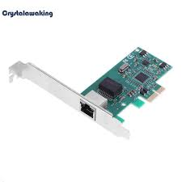

Ethernet Network Interface

1. Clearly label the following components (using arrows) on your image of the PC motherboard:
   1. CPU (and fan)
   2. RAM Memory
   3. Disk Drive Interface (IDE or SATA)
   4. GPU Graphics Processor (either on-board or Graphics Card)
   5. Sound Processor (either on-board or Sound Card)
   6. Wi-Fi / Ethernet Network Interface (either on-board or Graphics Card)

1. Research more in-depth about “CPU Processor Chip”. Make notes on the following:
   1. What different versions are currently available (speed and capacity)

There are two companies/CPU types: Intel and AMD. Some Intel processors are i-3, i-5, i-7, and i-9, with different versions, such as 6000U, 7000U, 8000U, and 9000U. Some AMD versions are FX 8-Core Black Edition, Phenom II X6 Black, Athlon II X2, and Sempron.

* 1. How the component has changed since the 1980’s

Before in the 1980’s, there used to be slower versions. Now, there are faster versions which allow you to do things much faster.

1. Research more in-depth about “RAM Memory”. Make notes on the following:
   1. What different versions are currently available (speed and capacity)

There is 4 GB Ram, 8 GB Ram, and 16 GB ram. The 16 GB Ram is obviously the fastest, while the 4 GB is the slowest.

* 1. How the component has changed since the 1980’s

The first computer ever had 64 KB of Ram. Now there is up to 16 GB ram. It shows improvement throughout the years.   
  
Link Used: <https://www.computerhope.com/issues/ch000984.htm>

**Level 3: Peripheral Devices**

**Outline**

Learn about how peripheral devices are connected to the back side of a typical PC tower case. Examine physical samples, select and labeling images found on-line and gain deeper knowledge by researching and reporting on specific components.

**Questions**

1. Find one (or more) images that clearly show the layout of the back of a typical PC tower case.   
   (i.e. Google images using keywords “Back Of PC Tower”)

Power Cord Monitor Interface

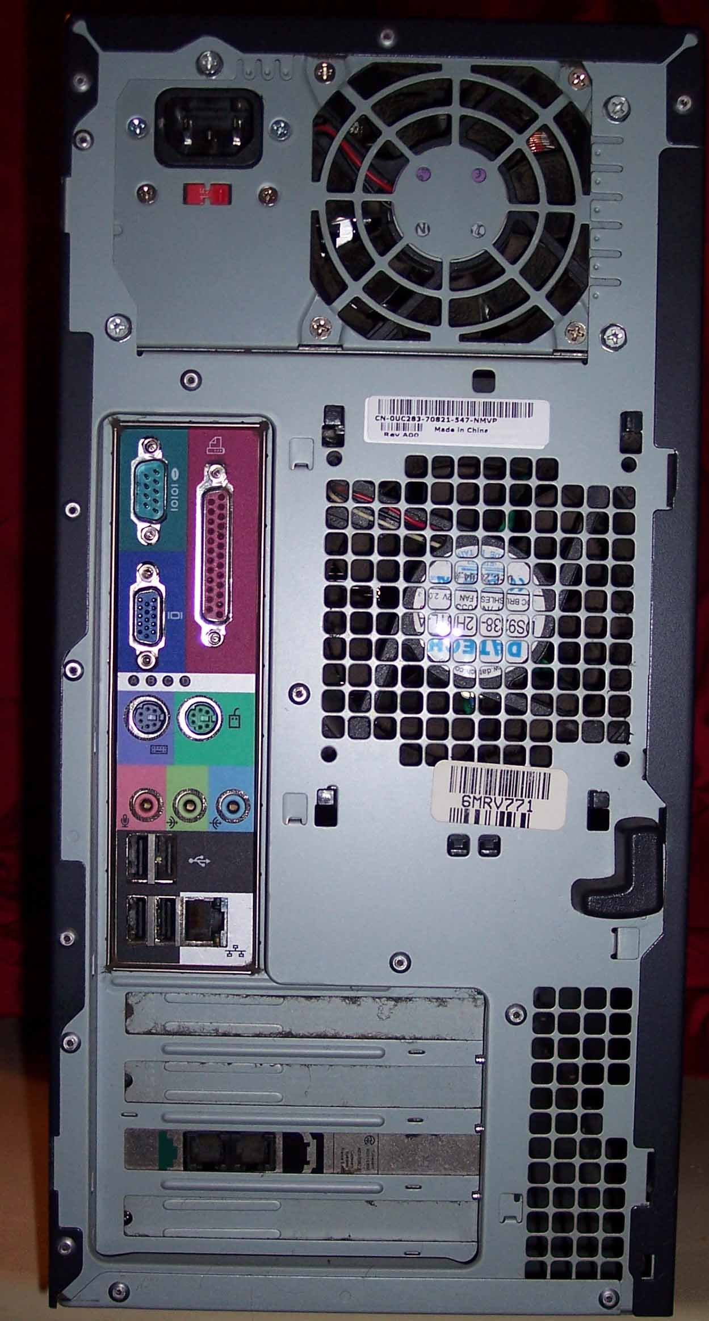  
Keyboard/Mouse Interface USB Ports Audio Inputs/Outputs(Whole Line) Ethernet Interface

1. Clearly label the following components (using arrows) on your image of the back of a typical PC tower case:
   1. Power cord and power switch
   2. Monitor Interface (VGA or DVI or HDMI)
   3. Mouse Interface (USB or PS/2)
   4. Keyboard Interface (USB or PS/2)
   5. USB Ports
   6. Audio Inputs / Outputs
   7. Ethernet Interface

1. Research more in-depth about “Monitor Technology”. Make notes on the following:
   1. What different versions are currently available (e.g. VGA / DVI, Flat Panel Technology)

The common different versions of Monitor inputs are Digital Visual Interface (DVI), Visual Graphics Array (VGA), and High-definition Multimedia Interface (HDMI).

* 1. How the component has changed since the 1980’s (e.g. Display Resolution, Technology)  
     Before, the resolution was really low. There wasn’t really any good quality. Now there are better quality screens that have better resolutions.

1. Research more in-depth about “External Portable Storage”. Make notes on the following:
   1. Floppy Disks
      * A soft magnetic disk
      * Slower to access and have less storage than a hard drive
      * Less expensive
      * Are portable
   2. CD-ROM / DVD / Recordable CD/DVD
      * Used to store mp3 and mp4 files
      * Playable on any computer, laptop or DVD player
   3. USB Memory Drives
      * Used to store any type of file
      * Usable with most USB Ports
   4. Compact Flash Memory
      * Used to store data on a small portable device
   5. Cloud Based Storage  
      - Used to store digital data in logical pools
      * Is better than physical storage devices as you don’t have to carry anything

**Level 4: PC Component Presentation**

**Outline**

Explore the development and features of a specific PC hardware component through deeper research and investigation. Work in partners to create a short presentation. Deliver the presentation to the class.

Each group will research a unique PC hardware component . Your specific topic will be assigned from the list provided below.

**Presentation Structure**

1. Explain what the PC component does and how it fits together with other components to make up a fully functioning PC.
2. Explain how the PC component works. Provide a diagram (image) showing the main parts of the component.
3. Research the current state of the art of the component in terms speed, capacity (size), and other related factors.
4. Research on-line suppliers that sell the PC Component. List the specifications for the available products and the cost (price).
5. Research how the PC component has changed and evolved since the early days of PCs in the 1980’s. Cover each of the following topics separately:
   1. Component Speed
   2. Component Size / Capacity
   3. Two other specifications specific to the PC component (ask Mr. Nestor)

**PC Component Topics**

|  |  |  |
| --- | --- | --- |
| **Topic** | **Partner 1** | **Partner 2** |
| CPU Microprocessor Chip |  |  |
| Motherboard Layout |  |  |
| Computer Graphics |  |  |
| Sound & Audio |  |  |
| Hard Disk Drives |  |  |
| Removable Disk Storage |  |  |
| Network / Internet Connectivity |  |  |
| Mouse / Pointing Devices |  |  |
| Monitor & Display Technology |  |  |
| Printers & Output Technology |  |  |